Allergy Shots to Improve Day to Day Life

By: Haadi Majeed

Introduction

According to the Centres of Disease Control and Prevention more than 50 million Americans suffer from allergies annually. That is about 3 in every 20 people whose immune system goes into a state of alert or attack for common everyday elements. Nearly anything from the natural world can trigger it, all with a large range of effects onto people ranging from sneezing to losing consciousness (CDC). These ailments can be lessened via a few methods such as antihistamines, decongestants, along with others, however these are all temporary fixes to the issue. A more permanent fix to allergies would be down the immunotherapy route.

The purpose of immunotherapy, or in this case allergy shots, is to expose the immune system to controlled levels of allergens. These injections are typically administered into muscle tissue near the shoulder of the patient weekly or alternating weeks. The objective is to force the body to build up an immunity to the allergens and introducing the immune system to increasing, yet controlled quantities.

**Discussion**

*Why Not Over the Counter Medicine?*

The primary difference between deciding if allergy shots are the correct route to take is determining if the problem is consistently throughout the year with inhibiting effects, or if it comes and goes with the seasons. It is recommended to ask a primary doctor or specialist, such as an allergist, to determine which route most applicable for every individual.

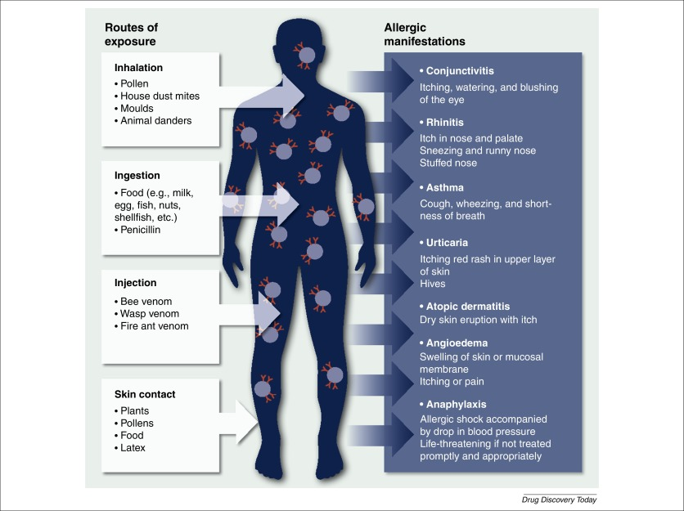If the situation is deemed to just need medicine, it is more probable that an antihistamine will be more effective. Over the counter antihistamine drugs such as Benadryl, Claritin, Zyrtec, etc. work by counteracting the histamines released by the immune system. Histamines are what activate nerves within the nose to release mucus and sneezing, along with other facial physical reactions to try to fight off the allergens (Harvard). Antihistamines share a similar protein to histamines which allows them to connect to the nerves within the body, blocking the histamines from connecting. These are often most effective after a few days of continuous use each consecutive day having better results to a variable limit.

*Figure 1: Common Allergens, Exposure Methods, and Reactions*

For people with mild, infrequent allergies, this solution is viable and effective, a tablet once or twice a day for a few days and the problem is solved. However, for people with more severe allergies, this approach will often not resolve much. Allergy shots, much like the antihistamine approach require a few consecutive doses before much of an effect is achieved. Unfortunately, the process takes a few months to get rolling, however, it can be supported via secondary medicine and can be taken in tandem to help assist during the initial stages of the injections. Where they begin to differ is the duration of the effects, a tablet will only last for about twelve to twenty-four hours at a time before a new dose is needed. The duration of the immunisation route is significantly longer depending on how many doses has been applied. After a few months, and eventually years, the need for other ailments becomes irrelevant, along with that, the immunisations will decrease further in frequency going to once a month until no longer needed. Past that point, most allergens will no longer pose a massive issue, however on days where allergen counts are higher than usually, the option to take additional supplements also persists to help aid in alleviating the immune system’s response.

*Dete.*

Test.

Glossary

**Antihistamine:** any of various compounds that counteract histamine in the body and that are used for treating allergic reactions (such as hay fever) and cold symptoms

**Histamine:** a compound C5H9N3 especially of mammalian tissues that causes dilation of capillaries, contraction of smooth muscle, and stimulation of gastric acid secretion, that is released during allergic reactions, and that is formed by decarboxylation of histidine

**Immunotherapy:** treatment or prevention of disease (such as an autoimmune disorder, allergy, or cancer) that involves the stimulation, enhancement, suppression, or desensitization of the immune system

*All definitions obtained from the Merriam-Webster Online Dictionary (www.merriam-webster.com/) or sources previously cited in this document.*

Worked Cited

“Allergies.” *Mayo Clinic*, Mayo Foundation for Medical Education and Research, 4 Aug. 2020, www.mayoclinic.org/diseases-conditions/allergies/symptoms-causes/syc-20351497.